Lab Exercise 4

[Based on Python data types, conditional statements & Loops]

Q1: Write a python program to add all the odd numbers from 0 to 20.

Q 2: Write a python program to find the sum of all integers greater than 100 and less than 200.

Q3: Write a program to display the sum of square of the first ten even natural numbers

- (2*2+ 4*4 + 6*6 + 8*8 + 10*10 + 12*12 + 14 * 14 + 16 * 16 + 18*18 + 20*20) Q4: Write a python program to display ascii characters from 65 to 90
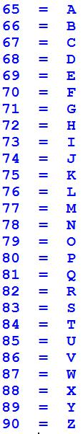

Q5: Display ascii characters from 48 to 57.

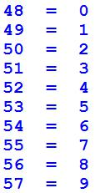

Q6: Display the following output with the help of Ascii character.
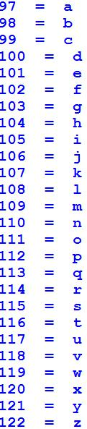

Q7: Write a python program for given a Python list you should be able to display Python list in the following order

L1 = [100, 200, 300, 400, 500]

Expected output:

[500, 400, 300, 200, 100]

Q8: Write a Python program to concatenate following dictionaries to create a new one.
Sample Dictionary :
dic1={1:10, 2:20}
dic2={3:30, 4:40}
dic3={5:50,6:60}
Expected Result : {1: 10, 2: 20, 3: 30, 4: 40, 5: 50, 6: 60}

Q9: Write a Python program to add key to a dictionary.
Sample Dictionary : {0: 10, 1: 20}
Expected Result : {0: 10, 1: 20, 2: 30}

Q10: Write a Python program to print out a set containing all the colors from a list which are not present in another list
Test Data :
color_list_1 = set(["White", "Black", "Red"])
color_list_2 = set(["Red", "Green"])

Q11: Given a Python list. Write a python program to turn every item of a list into its square

List1 = [1, 2, 3, 4, 5, 6, 7]

Expected output:

[1, 4, 9, 16, 25, 36, 49]

Q12: Program to count the number of each vowel in a string.

Q13:Write a python program to Access the value of key ‘history’ from the following dictionary-sampleDict = {

"class":{
"student":{
"name":"Mike",
"marks":{
"physics":70,
"history":80
}
}
}
}

Q 14: write a Program to Remove Punctuations from a String provided by the user. [Hint: use punctuation attribute of string module to get all punctuations (i.e. !"#$%&\'()*+,-./:;<=>?@[\\]^_`{|}~ ) ]

[Nested Loops]

Q15: Write a python program to print the Following:
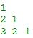
1
2 1
3 2 1

Q16: WAP to print the following asterisk pattern:
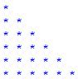

Q17: WAP to create a function traiangle to print the following asterisk triangle pattern:
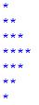

Q18: Write a python program to print following multiplication table on the screen

